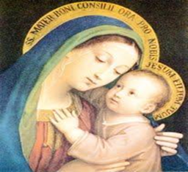
the CHAT

Summer 2025
DCCW
Quarterly Meeting
Quarterly Meeting
All Catholic Women are invited to join us (and bring a friend) at our evening DCCW (Diocesan Council of Catholic Women) Quarterly meeting on Wednesday, June 4th, in the Garden Room at beautiful Our Lady of Perpetual Help (Redemptorist) Catholic Church @ 3333 Broadway Blvd, Kansas City, MO 64111
Our evening begins with check-in at 5:00-5:30 pm followed by:
• A Living Rosary
• Program by Andrew Lynch – Pope Leo XIV
• You can make a difference in a child’s life: Please bring school supplies for children in need
• 50/50 drawing – bring money if you want to participate.
- Business meeting
• A light, springy dinner is provided (There is no cost but free will offerings are accepted and appreciated.) You will need to make a reservation so they will know how much food to provide.
• Reservations for dinner must be made no later than noon on Monday, June 2nd. Call Beverly South @ 816-304-1568 (leave a message please) or email her at marydccw@gmail.com

Our Vision: "To be a vibrant Catholic women’s organization devoted to making a difference for all women in our Diocese.” Our Mission Statement: “To promote among our Catholic women a greater devotion to Christ and the church, as we share the Blessed Mother’s role of bringing others to Christ, through spirituality, leadership, and service.”
Prayer for Pope Leo
+We pray that Pope Leo XIV be strengthened in his ministry. May he continue building bridges that connect us to one another. May he be an example of faith, hope and love. We pray that you give him joy in his work and a renewed fervor for your Gospel message.+
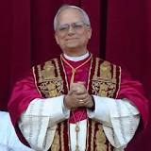
The Our Lady of Perpetual Help icon is also rich in symbolism.
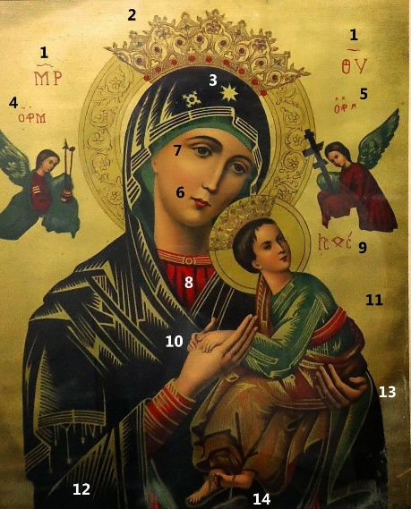
1. The Greek initials "Θεο τόκος", "Θεο τόκος" or "Theotokos," means Mother of God.
2. The Golden Crowns Our Lady's crown represents the many miracles she performed under the title of “Our Lady of Perpetual Help.”
The crowns on both Jesus and Our Lady represent royalty.
3. The Star The Star on the Virgin's veil reminds us that she is the Star of the Sea that leads us to the safe harbor, which is Christ.
4. Greek initial for “Saint Michael the Archangel”
Underneath these Greek letters, the Archangel holds the spear and sponge of Christ's Passion.
5. Greek initial for “Saint Gabriel Archangel”
Underneath these letters, Saint Gabriel holds Christ's cross and nails.
6. Mary's mouth Mary's mouth is small to signify her silent recollection and prayer.
7. Mary's sorrowful eyes Our Lady's eyes gaze away from Jesus and upon us. She is sorrowful and pleads with us to avoid sin and love her Son, Jesus, who died for us. Our sins resulted in His suffering. She wants and pleads with us to love Him.
Another interpretation includes her large eyes, which see our problems and needs. She always watches us.
8. Red tunic The color that virgins wore in the times of Christ. According to another interpretation, this color also represents royalty.
9. Greek initials ICXC ICXC means "Jesus Christ."
10. The hands of Christ Christ's palms face downwards. He places them in Our Lady's, which indicates that the graces of surrender are in her hands.
11. Yellow background Yellow symbolizes heaven, where Jesus and Mary are enthroned. Yellow also shines through their clothing, thus showing that they can bring heavenly happiness to weary human hearts.
12. Dark blue mantle Mothers wore a dark blue color in Palestine.
13. Mary's left hand She holds the hand of Christ in a posture of possession, which possesses the Christ. It is a consoling hand to all those she helps.
14. Loose sandal The fallen sandal holds various interpretations.
In one interpretation, the loose sandal represents Jesus running in haste to His mother, while gazing at the angels holding the instruments of His Passion and Death.
The sandal also represents Christ's Divine nature, "untied from the bounds of earth."
Our Lady of Perpetual Help, please pray for us!

