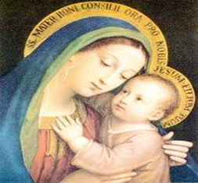
the Chat
DCCW Newsletter
Summer, 2024
YOU and a friend are invited to join us at our first evening DCCW (Diocesan Council of Catholic Women) Quarterly meeting on Wednesday, June 5th, at St. Jude the Apostle Catholic Church, 2001 S Broadway St. Oak Grove, MO
Activities for our evening include:
- Adoration and Confession - 5 PM
- Mass – 6 PM- 6:30 PM
- Dinner and Business meeting 6:45 PM – 7:30 PM – need to vote on Bylaws amendment
- Program by Fr. Bartlett – 7:30 PM- 8:00PM
- You can make a difference in a child’s life: Please bring school supplies for children in need
- 50/50 drawing – bring money if you want to participate.
- The dinner is provided by ladies of St. Jude. (There is no cost but free will offerings are accepted and appreciated.) You will need to make a reservation so they will know how much food to provide.
- Reservations for dinner must be made no later than noon on Friday, call Beverly South @ 816-304-1568 (leave a message please) or email her at marydccw@gmail.com
- See Project below, to bring with you.
Our Vision: "To be a vibrant Catholic women’s organization devoted to making a difference for all women in our Diocese.” Our Mission Statement: “To promote among our Catholic women a greater devotion to Christ and the church, as we share the Blessed Mother’s role of bringing others to Christ, through spirituality, leadership, and service.”
St. Jude and Danny Thomas, Yes One Person Can Make a Difference.
As a young man, Danny Thomas had a simple goal: to entertain people and be successful enough at it to provide for his wife and family. But work wasn’t easy to come by. As he and his family struggled, his despair grew. He wondered if he should give up on his dreams of acting or find a steady job. He turned to St. Jude Thaddeus, the patron saint of hopeless causes. “Show me my way in life,” he vowed to the saint one night in a Detroit church, “and I will build you a shrine.”
That prayer to St. Jude marked a pivotal moment in his life. Soon after, he began finding work, eventually becoming one of the biggest stars of radio, film, and television in his day.
And as one of the world’s biggest celebrities, Danny used his fame to fulfill his vow to St. Jude Thaddeus and to change the lives of thousands of children and families. https://www.stjude.org/about-st-jude/history/how-we-began

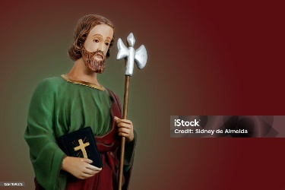
ST. JUDE: Jude is the Patron Saint of Hope and Impossible Causes and one of Jesus' original twelve Apostles. He preached the Gospel with great passion, often in the most difficult circumstances. Through the power of the Holy Spirit, he made profound differences in people's lives as he offered them the Word of God. https://shrineofstjude.org/
Here are the lyrics to the beautiful Saint Jude Hymn by Aaron Neville. Saint Augustine tells us that singing is praying twice so sing this beautiful song in times of need! https://www.youtube.com/watch?v=on-DbA-uPDY

DCCW Project:
Whispers of Wisdom from Old and Young
On a plain sheet of paper or index card please write one piece of advice. Please bring this with you to our next DCCW meeting and give to a board member:
If you are an elder (over the age of 18): Knowing what you know now, what is the best advice, comfort, or insight you can give a child going forward in her or his life? Talk to the child; perhaps tell them something you wish you would have known as a child.
This can be funny or serious but give it some thought.
Sign only your first name and age, NOT your last name or birth date.


If you are a child (under the age of 18): Knowing what you know now, what is the best advice, comfort, or insight you can give your mother or grandmother? What can you teach her about your life that she doesn’t already know? What can you tell her that might make her life better? This can be funny or serious.
Sign only your first name and age. Do not include your last name.


