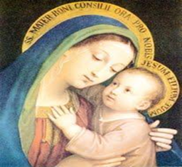
The CHAT
DCCW Newsletter,
Winter 2024
All Catholic ladies of the Diocese are invited to join us at our Winter DCCW (Diocesan Council of Catholic Women) Quarterly meeting on Wednesday, December 4th, 10 am – 1pm at Nativity of the Blessed Virgin Mary, 10017 E 36th Ter S, Independence, MO 64052 – look for the DCCW flag

Our activities for the day include:
- Sign-ins begin at 0945
- Praying the Rosary
- Business meeting
- Introduction of our annual Golden Rose Award for our young women- please see attached and on our website
- Blessing of Advent Wreaths – please bring your Advent wreath!
- Bring your Passport to enter into a drawing- be sure your name is on the passport!
- 50/50 drawing – bring money if you want to participate.
- Bake sale- bring goodies to sell if you want (or money to buy). Proceeds go toward the 2025 Golden Rose Award Celebration
- Our winter collection is for warm hats, scarves, gloves
- Game, discussions, and a free-will offering lunch
- You will need to make a reservation so we will know how much food to provide. Reservations must be made no later than noon on Monday, December 2; call Beverly South @ 816-304-1568 (leave a message please) or email her at marydccw@gmail.com
COME JOIN US AS WE FOCUS ON ADVENT
Prayer of Peace
God of peace, calm me and heal me.
Let Your peace reign in my heart at this very moment and for all eternity.
We make our prayer in the Name of Jesus Christ, the Prince of Peace. Amen.
– by Fr. Matthew Guckin

"Every year we celebrate the holy season of Advent, O God. Every year we pray those beautiful prayers of longing and waiting, and sing those lovely songs of hope and promise."
- Karl Rahner

Our Vision: "To be a vibrant Catholic women’s organization devoted to making a difference for all women in our Diocese.” Our Mission Statement: “To promote among our Catholic women a greater devotion to Christ and the church, as we share the Blessed Mother’s role of bringing others to Christ, through spirituality, leadership, and service.”

